

The Ewelme Benefice

The parish of Dursley
and
the parish of Uley with Owlpen and Nympsfield

Web Site – www.ewelmebenefice.co.uk

RECTOR
Revd Dr Juliet Jensen Tel: 01453 350810
E-mail: ewelmerector@gmail.com 077769 10890
SAFEGUARDING OFFICER FOR DURSLEY PARISH
Mrs Heather Arnold Tel: 07757 468371
E-mail: arnoldheather@icloud.com
CHURCHWARDEN.
Mr Chris Tyler Tel: 01453 299162
E-mail: cjtbrocco@gmail.com
BENEFICE ADMINISTRATOR – Mrs Clare White
Address letters to:
St James Parish Centre, Silver Street, Dursley, Glos, GL11 4NA
E-mail: ewelmeparishoffice@gmail.com Tel: 01453 549280

DIRECTOR OF MUSIC.
Mr Nigel Davies, M.A., B Mus., F.R.C.O, Tel: 01454 416867
PCC: CHAIRMAN.
Revd Dr Juliet Jensen (as above)
VICE CHAIRMAN.
Mr Chris Tyler (as above)
PCC SECRETARY.
Caroline Marrow Tel: 07517 778370
stjamespccsecretary@gmail.com
PCC TREASURER.
Mr Huw Clayton
E-mail: pccdursleytreasurer@gmail.com


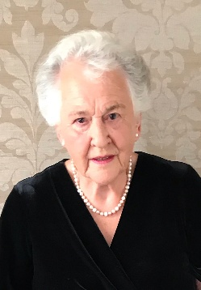


JUNE 2026

A Message from the Editors

Dear Readers

Welcome to our June edition, of the Messenger.
As we page up the weather has really changed, we’re not sure but we think summer may have finally come.
Please note views and opinions expressed within these pages are the writers own personal observations.

From Valerie and Judith (editors)
Front Cover: theme for 2026
‘In and around Dursley Parish’
Photo this month is
A View of Dursley from Longdown
by ©Steve White

CONTENTS

Revd David Vonberg writes 2,3
Safeguarding 3
Benefice Office thoughts 4
Diary dates 5,7,27,29,30
Eco News 8,9
Music 12 & 14
Diary for June 16,17
Books 20
Year’s Mind 21
Word of the month 23,24

Parish Registers & Flower Rota 32

Editors: Valerie Meares Tel: 01453 544677
Judith Staddon Tel: 01453 544312
Advertising please contact Philip Staddon Tel: 01453 544312
PLEASE SEND CONTRIBUTIONS TO:
Judith Staddon e.mail dursley.messenger@gmail.com
and copy in Valerie Meares e.mail: v.meares@btinternet.com
DEADLINE FOR JULY 2026 ISSUE

IS SUNDAY 14th JUNE 2026

SAFEGUARDING
Heather Arnold is the Safeguarding Officer for the Parish of Dursley
Tel: 07757 468371
Email: arnoldheather@icloud.com



Revd David Vonberg writes…

Dear Friends
Trinity Sunday is past and the weeks that lie ahead right through until the beginning of November are counted as part of the Ordinary season of the church calendar. With the odd exceptions the stoles and the hangings in a church are green. But this period of the year is anything but run of the mill. This month alone is a time when we remember many great men of faith but particularly we celebrate “Corpus Christi” the day of thanksgiving for Holy Communion. Here at St James we are fortunate that on every Sunday when there is a service here, we will celebrate Holy Communion, let alone every Thursday. That is riches indeed for a church in a small town, a quarter of the way through the 21st century. It is for many of us a profoundly meaningful act. Different denominations express the importance of celebrating the Eucharist, in vastly different ways. From some of the Scottish churches who celebrate once a year – because it is so special to them, - all the way to denominations who like to celebrate every day. How do we express its importance for us?
When I am serving from the “other side” of the Communion rail, one of the things that I watch for are the hands of those coming to receive. There are gnarled hands from a life of hard physical work, arthritic hands, there are the finely boned hands of those who have lived a life of writing and study, the hands of younger people, with a life ahead of them, and in some places where I have lived I have rejoiced in brown hands, black hands, yellow hands. All very different but all reaching out to receive the body and blood of Christ – however we understand that. All united in a need to receive the healing and strength of Christ as he gives himself to each of us at every Eucharist. That need is what unites us at the altar, however we differ in other ways. John Wesley, the eighteenth-century Anglican Priest wrote about the Eucharist which he saw to be both a confirming ordinance and a converting ordinance. That’s worth thinking about!

When I worked in the Hospice, it was hugely moving to offer communion to those who were dying. As they were no longer able to take the bread, I would touch their lips with one of the little sponges soaked in wine, you know the ones nurses use with their patients to moisten their lips. You could tell how this simple act, accompanying the words they knew so well, meant a great deal to them. I doubt if many of them in earlier life would have been able to say exactly what the Eucharist meant for them;
Come to that, I wonder how much that is true for most of us still today. Important though it is to go on exploring what it means, perhaps recognising the mystery of the Eucharist is even more deeply important, for we are touching on the holy things of God which defy total understanding.
Whatever you think of the Eucharist, whether it is important for you or not, I thank God regularly for this gift Jesus left to us in the words of St Paul, and then through the Gospel writers. I wonder whether we are closer to him as we celebrate than at any other time in our lives of faith?

David Vonberg

SAFEGUARDING
Heather Arnold is the Safeguarding Officer for the Parish of Dursley
Tel: 07757 468371
Email: arnoldheather@icloud.com

June Thoughts from The Benefice Office.... by Clare White

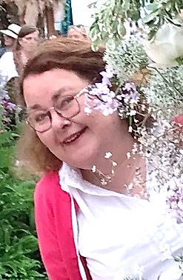
On 10th May (Rogation Sunday) I listened to Canon Richard’s sermon. He explained the meaning of the word Rogation – Rogo meaning “I ask”. It is something I regularly think through. Do I only ask, through prayer, for God in my life when I’m in need? Am I only using my God when I feel lost, unwell or in a quandary?
On Zoom with Revd Juliet and Moya Wallis I have been running a Pilgrim Course for new Christians. We have talked about our relationship with God and how prayers work, but not always in the way we expect, or in the timescale we had hoped.
My own relationship with God has had its challenges! I’ve said prayers that I thought he’d not heard. But as I have thought about it, they have been answered but have taken years to come to fruition. Our Lord has much better patience than we do.
I’m sure we have all at one time prayed with a bargain – “if you do this for me Lord, I’ll do this in return”. God doesn’t need our bargains, He loves us always, but I guess it makes us feel better if we can offer him something in return. Our own littles sacrifices.
When our answer to prayer does come it isn’t always as we had wanted or wished for. Our God only gives us what He feels we can manage or cope with and in the time we can accomplish it. He doesn’t need paying in kind because His love is infinitely greater than we can imagine.
But I still feel that many of us are only using God when we want something and often it can be material. Maybe we should ask for a money tree to be planted in our gardens!
I’ll keep coming back to this question I think, it is something that concerns me.
One thing is for sure when we are waiting to be heard through prayer God hasn’t given up on us even if at times, we have given up on Him.
One of Canon Richard’s prayers from Rogation Sunday –
God you made everything and everyone. You love your creation, bless your creation, land and sea, hills and vales, woods and fields, town and country and wilderness, plants, animals and humans
Amen
Julius & Dora Quiz.
Chris Morgan would like to thank everyone who participated in any way in the quiz on May 2nd to raise funds for the Julius & Dora Children’s Centre in Maseno, Kenya. It raised an amazing £742! Thanks to everyone who helped and those who attended or donated.
It will be back by popular demand on Saturday July 18th. Full details, see below or via Chris on chrismorgan194@btinternet.com.


APCM/PCC Meeting held on 17th May 2026…

Revd Juliet thanked Danny Parker for his year as Churchwarden, he wishes not to stand this year.
Chris Tyler was re-elected for 2026/27.
Sally Pearson stood down as treasurer and Huw Clayton has been elected.
Clare White resigned as secretary to the PCC, Caroline Marrow is the new secretary, someone will be coopted to take the minutes of PCC meetings and type them. If you think you could take on this role please speak to Caroline.
David Smith and Elizabeth Oakley have stepped down as Deanery Synod representatives and Chris Tyler was elected.
Synod meetings are now open so anyone can attend.
Four new members were elected to the PCC - Huw Clayton,
Jan Vonberg, Caroline Marrow and Sandra Longstreth.
Edwina Walton, Anne Shipton, Sheila Gardner, Heather Arnold and Joy Pepper are also members of the PCC for 2026/27.
The finance papers were circulated, Sally Pearson proposed the accounts for 2025, seconded by Caroline Marrow with attendees all in favour.
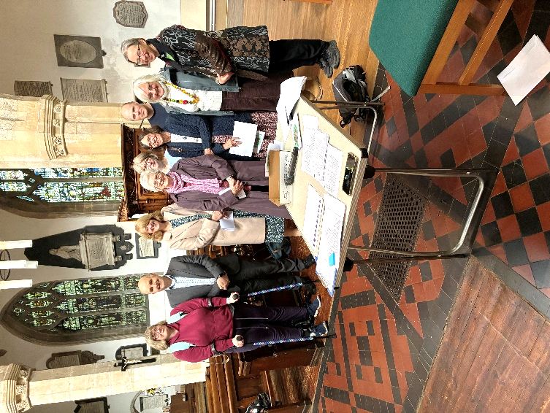
Sally was thanked by Revd Juliet for all the hard work she has put in over the last 7 years. Huw was thanked for agreeing to take on the role.
Church fabric committee reported that the boiler work has been completed and there are some other projects being worked on; such as the redecorating of the building and the maintenance of the windows.
The sound system will be updated/replaced and the pendant lights need to be changed.
Estimates have been obtained for all future work and grants will be applied for to help with the costs.
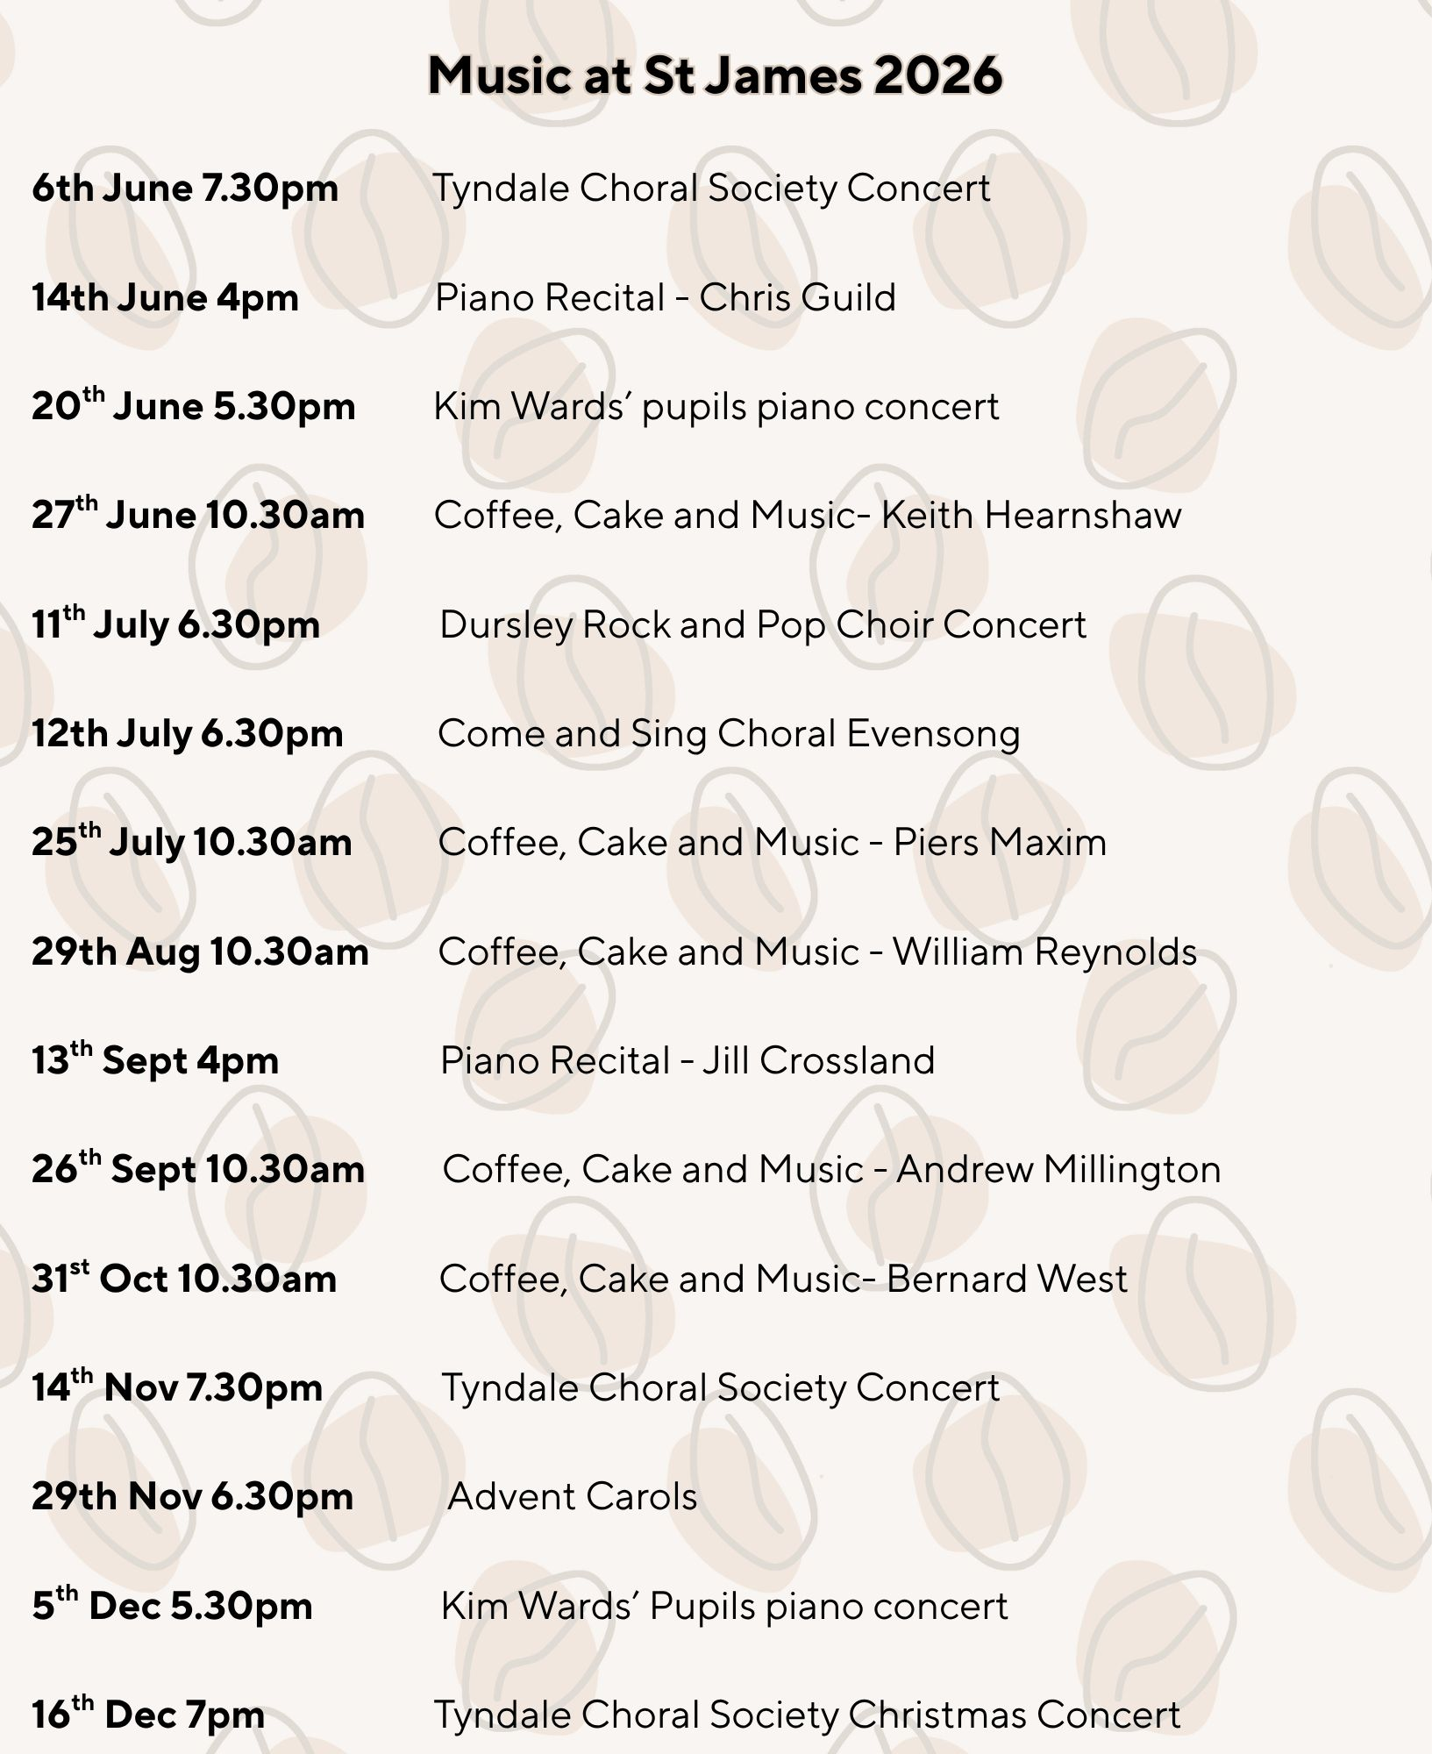
There is a booklet of reports from all the church groups if you wish to read about what is going on at St James the Great. Clare can email it to you if you wish.
2026/27 PCC, pictured at the first meeting. Photo by Judith
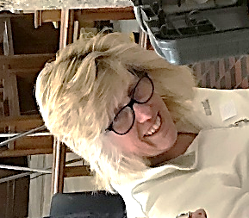
Eco Church News by Gill Mather


Recently I have been thinking about pollination and the importance of insect pollinators. For a flowering plant to reproduce it must be pollinated and then produce a seed which can then grow into a new plant.
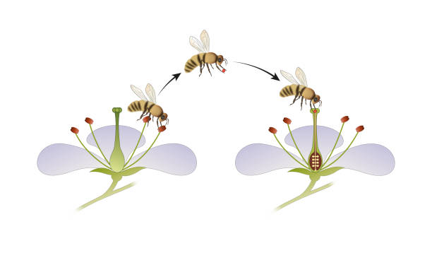
A flowering plant has a female part (the stigma). This is a tall tube-like structure which is located at the very middle of the flower. The flowers eggs are located at the base of the stigma. A flowering plant also has male parts (the stamen). These are several thin structures arranged around the stigma and they produce the pollen. For a flowering plant to produce a seed, pollen must join with the eggs at the base of the stigma.
Some plants self-pollinate, although most are cross-pollinated by animals or insects transmitting the pollen from one plant to another. Some trees such as Hawthorne have flowers and have cross pollination. Other trees including conifers have wind pollination.
Insects and some birds are attracted to the plant by nectar which is a high energy sugary liquid that they feed on. Nectar is produced in special glands (nectaries). These are found around the base of the flower.
As the insect feeds, pollen grains become attached to them. As they fly, the pollen is transported from flower to flower, the eggs fertilised and the flower seeds formed.
Not only butterflies and bees are pollinators, but also are wasps, beetles flies and moths. Moths pollinate flowers that bloom evening and night.
To attract pollinating insects to their flower, they produce wonderful perfume and have bright colourful petals. These can be beautiful


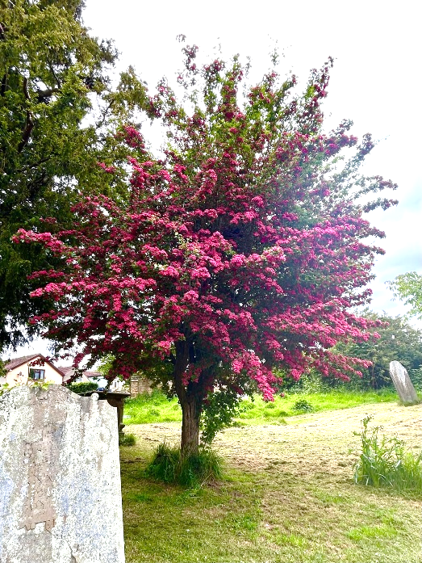

Photo by JR

Beautiful local flora attracting the pollinators

Photo by PR
Photo by AM
Other Eco News –

You may hear of the People’s Emergency Briefing Film regarding the Climate Crisis and the Nature crisis? In simple terms, it is a 45-minute film developed by the National Preparedness Commission aimed at enhancing the public’s awareness of the climate and environmental issues we face, as well as developing dialogue and positive responses. Screenings across communities are aimed at bringing together community leaders, faith leaders, MPs and constituents. There is a screening of the film at the Chantry Centre, Dursley, on Sunday 7th June at 7.30 pm. Jan Vonberg has already seen it and describes it as “challenging and at times shocking, but with positive solutions proposed. Introduced by naturalist Chris Packham, the film includes well-argued contributions from experts in a variety of fields, and responses from well-known faces such as Deborah Meadon and Jennifer Saunders as well as members of the public. These are issues we should all be debating “.

References woodlandtrust.org.uk/blog/2019/04/
what-is-pollination/butterfly-conservation.org/news-and-blog/moths-are-more-efficient-pollinators-than-bees-new-research-shows
If you would like to get involved with St James Eco Church, please speak to Gill Mather or Jan Vonberg


June and Night Angel
Acrostic Poems….by Sally Hayward


June is
Usually known as the hottest month of the year
Needless to say
Everybody enjoys the sun.

The Night Angels

Together for a safer community
Having that
Extra support and you
Never do you have to be alone
Important
Giving
Hope and help for women
This organisation is ran by team of women

And they all volunteers
Never say never
Giving courage and reassurance to
Each and every woman's needs
Less
Stresses, the Night Angels are never far away





MUSIC NOTES FOR JUNE

The Feast of the Ascension seems to get rather less attention these days, even though I thought it was a “day of obligation” for communicant members of the church of England (Canon Richard will correct me if I'm wrong!). However, for me the Ascension brings back a rather embarrassing memory which relates to the hymn “Hail the day that sees him rise” which we only sing once a year.
In the 1960's Blackpool's education Department was still in the hands of people of the Christian faith, and during term time, once a month all pupils in primary and secondary schools were expected to attend their nearest church for a short service at 9.00am. Registers were taken at the churches, and school began at 10.00am. Whilst there were services for non-conformists and Roman Catholics, the majority chose to attend the Anglican church, and St Paul's church was no exception. Seating close to 1000, it was full on these occasions, but 9.00am on a Thursday morning was a rather inconvenient for someone at work to come and play the organ, so aged thirteen the job fell to me, and I have to say it was something of a thrill to accompany such an event. It was at the Ascension Day service where I made my faux pas. We began with great gusto singing “Hail the day that sees him rise”, but by the second verse it was apparent that something as not quite right as the words didn't seem to fit, but we ploughed on regardless until we ended in a shambles........Back at school, naturally I got some stick from my fellow classmates but a kindly comment from my History teacher was “shame about not repeating the first line”, and immediately I realised what I had done, causing chaos and confusion on a pretty big scale! It was a lesson well learned........
Music for June
7th am Though I speak with the tongues – Bairstow Nicholson in F
14th am God so loved the world- Chilcott Darke in F
pm A Clare Benediction - Rutter Rose Responses
O Lorde the Maker of all Things - Joubert
Collegium Regale Howells
21st am Informal Service
28th am Benefice Service at Uley.
Music notes contd on page 14……

Chris Pengelly
Gardening Services

Tel: 07917 440925 Email: cwrpengelly@hotmail.com

chrispengellygardeningservices.webador.co.uk

For All Your Gardening Needs



D A HILL

Plumbing, Building, Roofing,
Decorating, Plastering.

Tel: 01453 543249
e.mail: dahillbuilding@sky.com

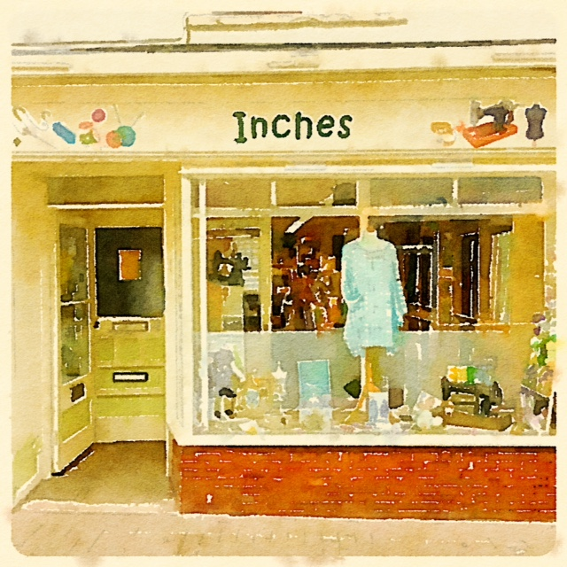
Fabrics, Wools and haberdashery
Buttons, ribbons and patterns
Knitting and sewing lessons
39 Parsonage Street,
Dursley, Glos, GL11 4BP
www.inchesfabrics.co.uk



More Music Notes……

Sunday June 14th has been designated RSCM Sunday. We are affiliated to the Royal School of Church Music and hopefully will be part of the “Choir Project” which has been mentioned previously. The RSCM is a Christian music education organisation dedicated to the promotion of music in Christian worship, in particular the repertoire and traditions of Anglican church music, largely through publications, training courses and an award scheme.
The RSCM was founded in 1927 by Sydney Nicholson (we will be singing his Communion Service in F on 7th June) and for many years had its headquarters at Addington Palace, Croydon, an opulent building dating from 1770 which has been home to many different things including a residence for six Archbishops of Canterbury, a wartime Red Cross facility, and, before becoming a wedding venue, from 1954 to 1996 the home of the Royal School of Church Music.
Today the RSCM has its headquarters at Sarum College Salisbury, and with some 8,500 members in 40 different countries is one of the world's largest church music organisations. Some of our (older) choristers remember residential courses at Rossall School (on a wind-swept site between Fleetwood and Blackpool) when Cecil Adams was Dursley's formidable organist and choirmaster. Since those days, the RSCM is rather more compact, except in management where, like just about everything else, the hierarchy has increased while the membership numbers slowly decline!
However, we will mark RSCM Choir Sunday by giving thanks for the pioneering work the organisation did to establish and bring church music to far-flung parts of the globe, and for what it's doing now to assist the C of E in reviving choral singing in schools.

The Coffee, Cake and Music recital for June will be given by the irrepressible Keith Hearnshaw who is making a return visit. An extremely skilled organist with the wonderfully up-beat, flamboyant presentation style of the late Carlo Curley, it's a recital not to be missed!





This Photo by Unknown Author is licensed under CC BY-NC-ND
Hair by Sam

Mobile Hairdresser

Based in Dursley, Gloucestershire
Contact 07577956087
Email samanthaw305@gmail.com

Competitive rates for OAP’s








June 2026

(Joining Zoom details on Ewelme Benefice website)

Wednesday 3rd June
6pm Evening Prayer via Zoom
Thursday 4th June
9am Morning Prayer in St James
10am Holy Communion at St James
Friday 5th June
OFFICE CLOSED
Saturday 6th June
7.30pm Tyndale Choral Society Summer Concert
Sunday 7th June – 6th Trinity 1
10am Parish Holy Communion Service at St James
Tuesday 9th June
2pm Communion at Holly Oak Care Home
Wednesday 10th June
6pm Evening Prayer via Zoom
Thursday 11th June
OFFICE CLOSED
9am Morning Prayer in St James
10am Holy Communion at St James
11.15am Communion at Henlow Court Care Home
Saturday 13th June
5.30pm Kim Wards’ pupils’ piano concert
Sunday 14th June – Trinity 2
10am Parish Holy Communion
6.30pm Choral Evensong
4pm Chris Guild Piano Recital

Wednesday 17th June
OFFICE CLOSED
6pm Evening Prayer via Zoom
Thursday 18th June
9am Morning Prayer in St James
10am Holy Communion at St James
Sunday 21st June – Trinity 3
8am Said Holy Communion at St James
10am Reflective Worship at St James with baptism
10am Shine! Informal worship at Dursley Academy CofE School
Monday 22nd June
7.30pm Sounds of Music Concert
Tuesday 23rd June
2pm Communion at The Hollies Care Home
Wednesday 24th June
OFFICE CLOSED
6pm Evening Prayer via Zoom
Thursday 25th June
OFFICE CLOSED
9am Morning Prayer in St James
10am Holy Communion at St James with Lectio.
Friday 26th June
OFFICE CLOSED
Saturday 27th June
10.30am Coffee, Cake and Music. Recitalist – Keith Hearshaw
Sunday 28th June – Trinity 4
10am Benefice Holy Communion at St Giles, Uley
Tuesday 30th June
6pm Staff meeting at The Rectory


J BROOMHALL (Butchers) Ltd
32 PARSONAGE STREET DURSLEY

HAVE BEEN SUPPLYING CUSTOMERS FROM DURSLEY AND SURROUNDING AREAS
FOR MORE THAN 50 YEARS AND HOPE TO DO SO
FOR MANY YEARS TO COME...........

Tel: 01453 542097 e.mail: dursley@jbroomhallltd.com
.



CASTLEGATE WI

Meetings on the
3rd Wednesday of the month
9.45am to midday
at The Community Centre,
Rednock School.
COME AND JOIN US

We have interesting speakers and time to socialise.
Most months we organise to go out
to lunch after the meeting.
We have Coffee Mornings most months (not one in June).
You will in fact find many contacts in
St James on a Sunday.

OUR NEXT MEETING IS ON Wednesday 17th June
Speaker: Eric Moore - Everest the Ultimate Trek.

Contacts:
President:
Glenys Muir 01453 543391
Secretaries:
Val Sheen 07842 427452
Judith Staddon 01453 544312





Books @ St James Church, Joy Bell writes……

A Literary Homecoming.

When we unpack the bags and boxes of donated books, we never quite know what treasures we’ll uncover. Earlier this year, we received a particularly large donation from John Ewer — so large, in fact, that it took us nearly four weeks to sort through it all.
Among the collection, three small leather-bound volumes caught my eye. They were clearly part of a set, and inside one was written:
“M. E. Hodson, Compton Hall, Wolverhampton.”
Being from near Wolverhampton myself, I recognised Compton Hall immediately. The Grade II listed house was built in 1845 and later purchased, in 1885, by William Hodson, a partner in a local brewery.
His wife, Mary Elizabeth Hodson, was the “M. E. Hodson” named in the books.
I grew up in Codsall Wood, not far from Wolverhampton, where there was a local farming family also called Hodson. Naturally, I wondered whether Mary Elizabeth Hodson of Compton Hall might be connected to the Hudsons I remembered from the 1960s and 70s — Bill and Molly Hodson (likely William and Margaret) and their daughters, Barbara and Margaret. Despite my best efforts, I couldn’t trace a link between the Compton Hall Hudsons and the Codsall Wood family.
Compton Hall itself was converted into a hospice fifty years ago, so I contacted them to share what I had found. After sending photographs and exchanging a few messages, I was delighted to parcel up the books and return them to Compton Hall.
I still don’t know how they left the Hall’s library or how they eventually found their way into John Ewer’s collection. But it felt good — and rather fitting — to send them back to where they belonged.

Books pictured right…..
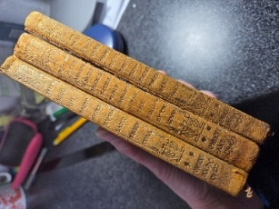
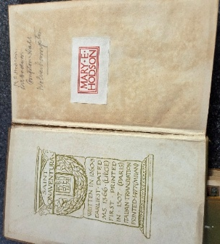


Clive writes…..It was lovely to meet two of the Stroud Night Angels, which was our May charity, and thanks to your generous donations we raised £310. I also believe they gained a volunteer to join their team

This month, on 13th June, we will give any donations we receive to the Tiny Toads playgroup. The playgroup operates in Stinchcombe Village Hall on Monday mornings, and they need to develop their reading area with a folding bookcase, and hopefully some beanbags too, and that will create a nice space for reading.

From the Parish Registers…
Year’s Mind in June
1st Patricia Averiss 2017, Philip Hancock 2019, Margaret Bryant 2025
2nd Terry Adams 2019, Winifred Pretty 2024
5th Tom Arnold 2003
6th Stuart Cornock 2001, Jane Gardner 2016, Brenda Gardner 2017,
7th Lionel Ayliffe 2013 Eileen Boyles 2018
8th Jill Hill 2016
9th Jack Edward Bryant 2006
12th Roy Kelly 2016
14th Elton Chappell, Alice Rose Clarke
16th David Pagett 2008
18th Janet Philp 2023
19th Dorothy Warner 1999, Margaret Parry 2018
20th Marcia Turner 2017
21st William Greenwood 2022
24th Mabel Owen 2005, Mary Haviland Minchin 2006, Marion Osgood 2025
25th Patricia Welton 2008
26th Hilda Wills 2002, Iris Jones 2009, Barbara Greenwood 2023
27th Gill Littleford 2018. 28th Bridget Waters 2008, Bob Wood 2020
30th Wyndham Jones 2015
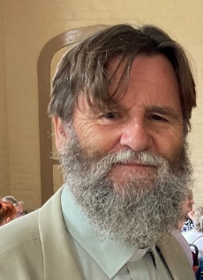
What is it to be human? ….by Canon Richard Morgan

Just an accident of random development? A brief and ultimately meaningless journey from birth to death in 70 or 100 years, if we last our full span? A little pile of chemicals all too briefly held together by the biology, physics and chemistry of life, which clothe the bones with flesh and shake them about in thought and will and feeling and activity for a few years before they disperse again? Or are we made for eternity, to relate to a love that is shaping all things, at enormous cost to Itself/Himself/ Herself – to relate to God? ‘To be or not to be, that is the question,’ said Shakespeare’s Hamlet. Are we finally for being or for nothingness?
And what is ultimate Being? is it just the chaos of meaningless rising and falling of universes, bursting out into order, and then sucked back into nothing, to black holes, or spreading and declining into a patternless chaos, entropy? Or, through and beyond this, is there an ultimate life and love, which we can share?
The last day of May this year is Trinity Sunday. This is the June Messenger, but it should get to you before the end of May! And the Sundays for the next few months are named after the Trinity – Sundays after Trinity. Calling God Trinity is not playing some sort of theological numbers game. God as Three in One is the God of love, One, yet not a mere single, but a rich relationship of love, into which we can be drawn and enter, by God’s generosity. God is not just a master and Lord who wants slaves, but a Father / Mother, a Brother, a life and Power of Love, who longs to draw creation into the Divine family life and Friendship.
So we are not accidents, not mere mortals. Our life is not found in consuming or self-assertion in power or greed. We are made to love and be loved, to care for one another, and to respond to an ultimate Care and Goodness, the God who is love. There is no more important question in our lives or the universe than whether we – finite creatures in ourselves – respond to the call of the ultimate Love. God grant we do accept and receive in trust and love.
So here are two prayers which express a response to God:
God, Holy Trinity, you are love;
you live by love;
you share your life and love with us and give us yourself
through Jesus and the Holy Spirit.
Help us receive you, and respond in trust and love,
now and for ever. Amen.

God, the true and only God,
we praise you that you live eternally
with your Perfect Word, the Full Expression of Yourself,
and with your Spirit, your Life and Power,
in the Unity of Love,
like a Parent and a Child and the Love between them,
Lover, Beloved and Love.
We thank you that you speak to us in your Word as Jesus,
and through him you share your Life and Love, your Spirit, with us.
You pour yourself out and call us into your life,
to live as your children through the Spirit.
May we receive and live by your love,
forgiving, caring, seeking the good of others,
as you do in yourself and for creation. Amen.

ENTRIES FOR WORD OF THE MONTH for MAY which was Loquacious

Paul Prodger
Whilst I was at work I had no time to talk. Now that I've retired, I chat all the time to everyone. My wife tells me I am Loquacious.

Jean Gardiner
I have a very loquacious friend
He's impossible to shut up
He greets me in the morning
Like a very excited pup
He chatters all day long
And sometimes sings a song
He tells me funny stories
Some I pretend I haven't heard
His vocabulary is vast
and sometimes very weird
He butts in when friends visit for a chat
Calling "Hello, wipe your feet upon the mat"
Who is this friend, I hear you call?
Well, it's Jacob, my beautiful Macaw!
As usual all the entries were very good and we have chosen one by Richard.

Well! Well! Well! Oh, goodness gracious!
We all know folk who are loquacious,
And, at the very least temptation,
Will launch into extreme loquation.
[I know there isn't such a word,
But I won't be by that deterred
From using it, and minting new
a word for use by me or you!]
They rabbit on and on and on,
And on and on and on and on,
Until we're longing to be gone!
-Why 'rabbit on' I do not see,
Rabbits don't have loquacity.
Their squeaks are very short and brief.
A rabbit would provide relief
For those who suffer from audacious
Protracted talk by the loquacious.
Oh, goodness me, if I go on,
You'll say, 'You're the loquacious one,
A tedious, very boring natterer,
A really irritating chatterer!
Or else you'll simply groan and weep,
Or, if you can, you'll fall asleep.

Can Richard Morgan.

Valerie, Clare and Judith






WORD OF THE MONTH COMPETITION
Each Month there will be a new word which we need you to fit into a sentence. The sentence, which best conveys the meaning of the word and will be judged by the editors and Benefice Administrator, will be the winner. There will be a small prize.
The word for July is mollify.
Send entries to the Office, Valerie or Judith by 20th June



WHAT CAN I DO? / WHAT I CAN DO!...by Jennifer Kendrick


It was a shock to see a beggar on the street in Dursley recently. Difficult to tell her age, but under 30, pretty face but skin wrinkled with dehydration, long dark hair, probably a wig, pitifully thin, playing with rosary beads and mumbling to herself. I hurried by, embarrassed and unsure what to do!
Later, I felt drawn to pass that way again and this time plucked up courage to stop to ask her, her story. She just wanted prayers for her children, nothing else! She was gentle and so sad, having been brought to UK from, I guess, eastern Europe, having been promised work and a better life! But there was no job so she was unable to send money back home! No escape!
A passerby snarled and shouted at me for getting involved but that made me stay with her! Somebody from Gravity bought her fish and chips which she swallowed like a starving dog, and a bottle of drink which gave her dry mouth a boost! Another person phoned the police for help but they declined as there was no emergency!
I was aware of a stranger sitting on the nearby bench watching intently and the poor lady becoming more anxious as minutes ticked by and I was trying to think of what to do next. Then, as if by magic, she gathered her few belongings and disappeared in the busy street, closely followed by the man!
I learnt later from another person, that she had been dropped off earlier from a big black car! Clearly an innocent victim of trafficking, she left no clues that could lead to an end to her ordeal, or even any possibility of relief!
I did what I could, which is a comfort of sorts, and there are many more like her who need our prayers. Now that IS something we can ALL do wherever we are, whoever we are, any age, any time without fear or favour. It might just make all the difference!


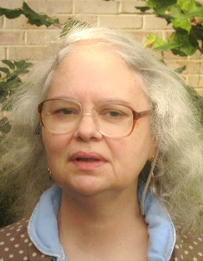
Elizabeth and David Smith say…….


Thanks to all for support of our twentieth wedding anniversary.
To celebrate we went to
St Ives and Elizabeth painted the picture (left).
Sea at St Ives on our anniversary holidays.

A Night Remembered
It started with an old map at a country fair, and the map so departed from modern reality, that it sparked memories in the passer-by of an episode of past disaster.
For what was there then, and what was not there now, was a bridge. Straight on the map, the line joined river between forest and docks. A passage for coal one way and school children the other, hopeful of competing in sporting events on the other side.
This situation continued for almost ninety years until one night. You could hear it across into Wales they said at the time. All across the river and the forest. Suddenly a huge ‘whoosh’, and when witnesses sought the path of the sound, a fierce orange glow showed the river burnt from shore to shore after petrol and oil cargoes caught fire.
Dense fog had enveloped the scene. Two tankers, trapped in fierce currents when their dock destination dissolved in the mire, were driven up-river on some fatal convergences. They could not resist the iron structure either, with its magnificent span of twenty-one piers. Colliding, they spun together, hitting a pier and killing five sailors.
But fate perhaps had a way of its own. A local hero had the presence of mind to turn off the gas from the mains before flames spread across the river, and the last train crossed ten minutes before the tanker-strike on the ill-fated structure above.
Wading birds on the mudflats today, are likely unaware at certain low tides, that the ravenous river with its tidal range and strong currents, only gives up secrets of the bridge and the tankers, occasionally. Time and tides have washed away much of the structures. However, the map remains to tell the start of the story.
The Severn Railway Bridge was a historic railway crossing between Lydney and Sharpness built in the 1870s and eventually demolished after its collapse on the night of 25th October 1960.
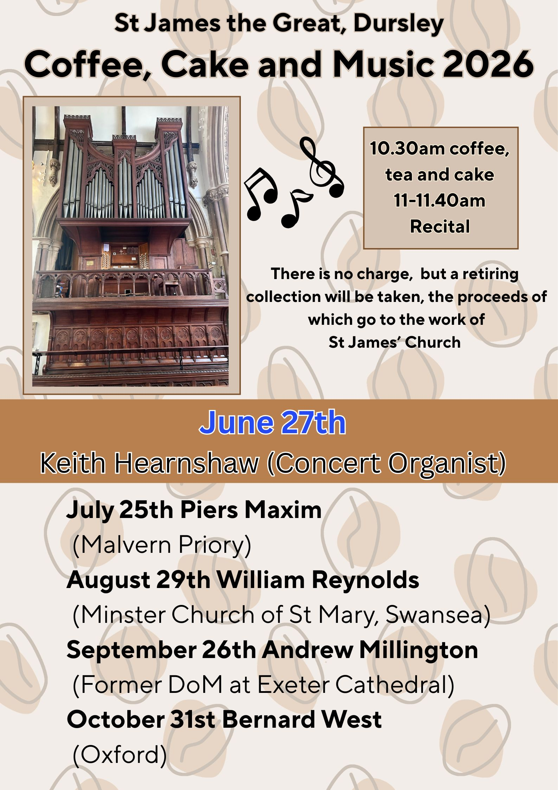
June 2nd 1953 Coronation of Queen Elizabeth II.
Celebrations in Woodmancote…

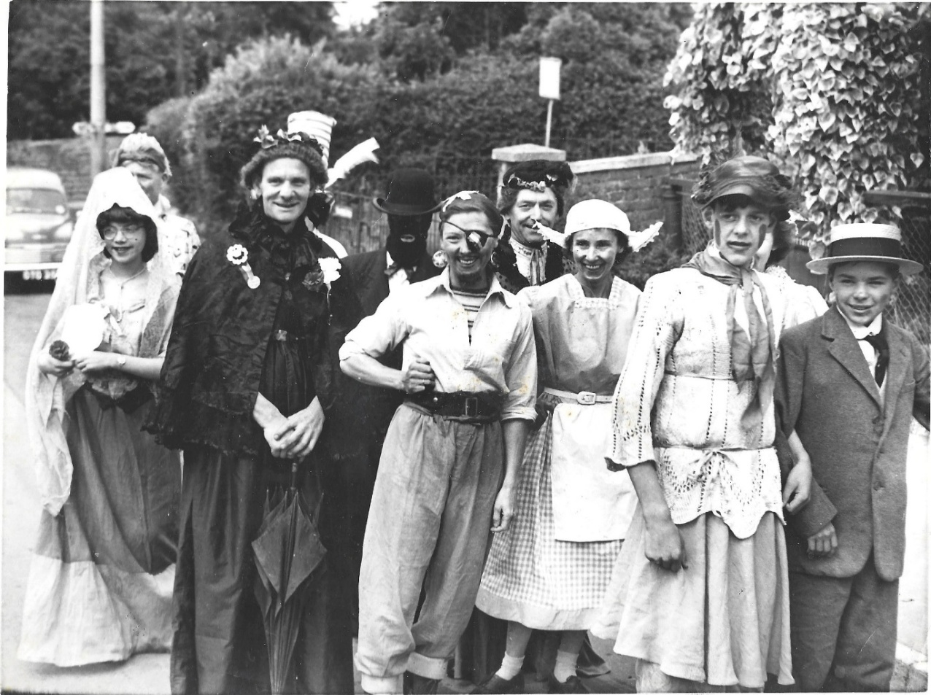

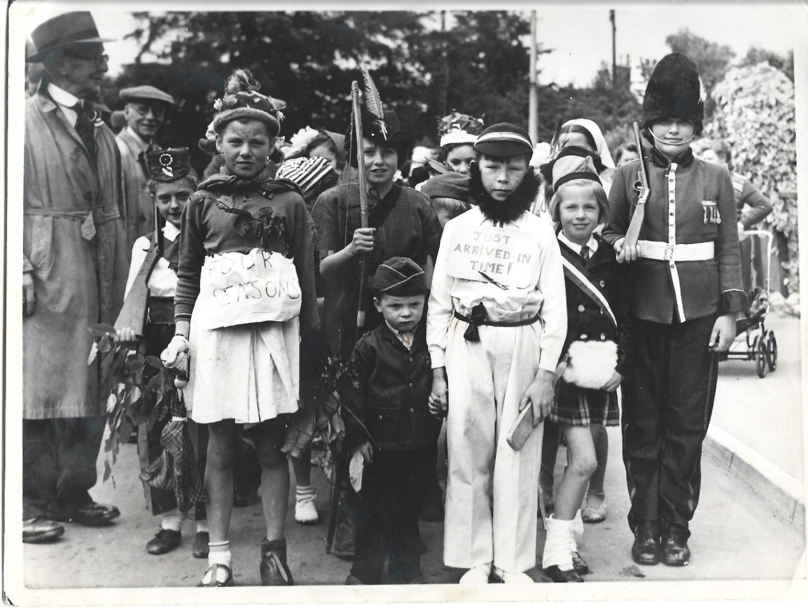

Dear Reader you may recognise some of the faces in these pictures……


The Dursley
Pet Shop

17 Parsonage Street,
Dursley,
Gloucestershire

Telephone (01453) 542798

Pet foods & Accessories,
Animal Feeding stuffs,
Seeds, Bulbs & Plants,
Garden sundries

Large Range of Wild Bird Products




FROM THE PARISH REGISTERS.
BIRTHS, MARRIAGES ^{AND}
DEATHS

FUNERAL SERVICES:
We share our thoughts and prayers
with the families of those who mourn
the loss of those they love.
Interment of Joan Spilsbury’s ashes at Kingshill cemetery on 20th May
Ethel Shill’s Funeral at St James on 27th May 2026

FLOWER ROTA

June 7th & 14th
High Altar Sandra Longstreth
Tanner Chapel Anne Shipton
Lady Chapel Kim Pugh
June 21st & 28th
High Altar Clare White
Tanner Chapel Steph Say
Lady Chapel Margaret Lloyd

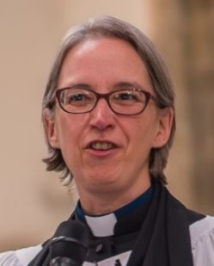

PASTORAL CARE
If people are in need, unwell,
at home or in hospital
Please contact the
Revd Dr Juliet Jensen.
Tel: 01453 350810 or 07776 910890


Mrs Gregory – Principal
Dursley CofE Academy,
School Road,
Dursley,
GL11 4NZ
t: 01453 542304 e:admin@dursley.gloucs.sch.uk
e: www.dursleycofeprimaryschool.org.uk
Diocese of Gloucester Academies Trust.
Registered in England Company Number 08149299

THE PARISH CHURCH OF ST JAMES THE GREAT
DURSLEY

St James Church is open each day
between 9.00am and 5.00pm.

Useful Telephone Numbers

TO BOOK THE PARISH CENTRE.
Clare White Tel: 549280
E-mail: ewelmeparishoffice@gmail.com

BELLRINGERS
Elizabeth Byrne Tel: 07788 800849

CHOIR
Anne Shipton Tel: 07557 784858
David Wood Tel: 01453 545073


Follow us on Instagram: ewelmebenefice


Follow us on Twitter: @EwelmeBenefice


Visit us on Facebook: Ewelme Benefice Family

